# Login Page



**Create New Account**

Already Registered? **Login**

N A M E

Lorem Ipsum

E M A I L

Lorem [Ipsum@greatsite.com](mailto:Ipsum@greatsite.com)

P A SSWO R D

******

**sign up**



**Login**

Sign in to continue

E M A I L

Lorem [Ipsum@greatsite.com](mailto:Ipsum@greatsite.com)

P A SSWO R D

******

**sign up**

# Customer Dashboard





**Send new Parcel**

View request History Errand status tracking

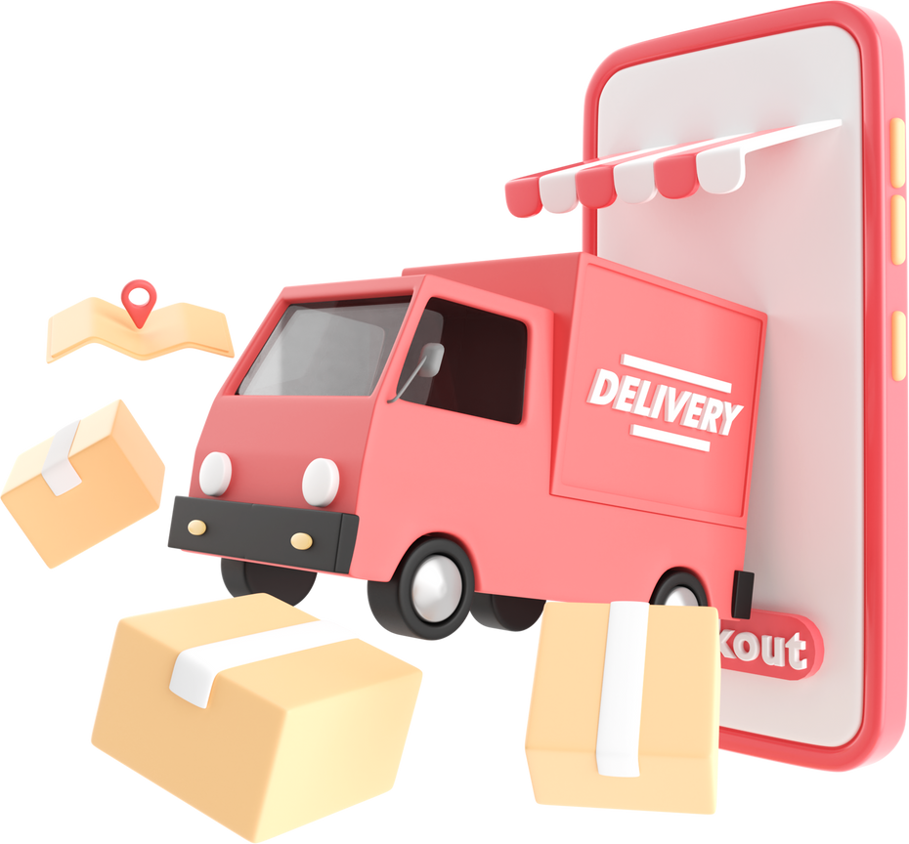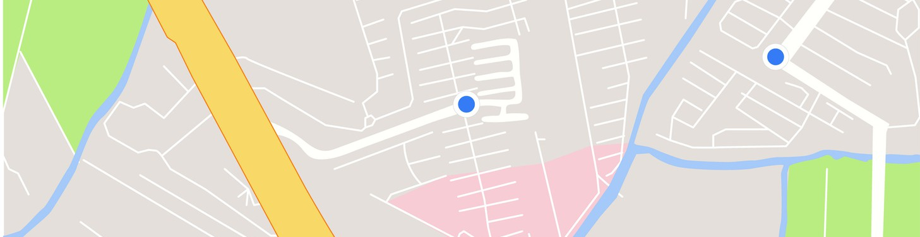

SIGN UP FOR FREE

**Join as merchant**

or

TRACK YOUR PARCEL

Tracking id TRACK

Phone Number

(viewStatus)

List of active/ completed errands

# Submit New Errand Page

## From Postcode To poscode Weight

**KG**

## Calculate

Submit New Delivery details: Fields for:



Type Description

Pickup & Drop-off addresses

Estimated Quote/Amount shown TAC

Button to submit request Trigger for payment page

# Payment Page



Bank 1

Bank 2

Payment method selection TAC

Key in detailed online banking / card

Sumarize order deliveryAmount to pay "Confirm & Pay" button Confirmation message



Order complete notification Summarize info customer order delivery

Estimate day

Generate Tracking Number

# Runner Dashboard

**Schedule Page**

Show performance: completed count & average rating

All List of assigned errands

Mark errand as completed



View/update availability

Message Customer Display

# Runner Schedule Page

**Runner Dashboard**



Manage available time slots

Calendar/time selector

Save/update availability

# Communication / Messages



Inbox-style message view

Chat or message view with sender and content Send message to another user (via sendMessage)